*A fee of $1.00 will be charged for all reissued licenses*
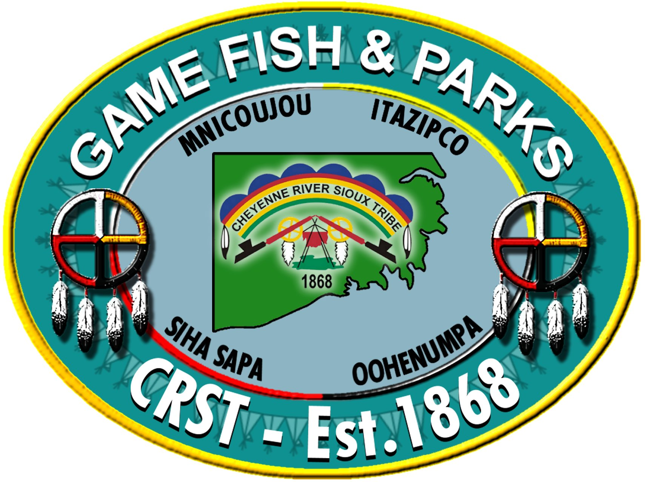
Cheyenne River Sioux Tribe
Game, Fish & Parks – Wildlife Division
2014 Fishing Season, Fees & Limits

*A $10.00 processing fee will be charged for nonmembers*
*All Seasons, Fees and Limits Are Subject To Change*

Fishing Season
Start Date: Saturday, January 4th 2014
End Date: Sunday, December 28th 2014
Season Length: Annual

Season Fees
Status | Cost
Elderly / Income Eligible / Handicap | Free
Member / Affiliated Tribal Member | Free
Nonmember - Resident | $30.00
Nonmember - Nonresident | $30.00

Season Limits
2014 Daily Fish Possession Limits
Fish Species | CRST Impoundments | Oahe Reservoir, Moreau and Cheyenne Rivers
Large Mouth Bass | 5 | 10
Small Mouth Bass | 5 | Unlimited
Walleye, Sauger, Saugeye | 5 | 15
Rainbow Trout | 5 | 10
Chinook Salmon | NA | 10
All Pike Species | Unlimited | 10
Yellow Perch | 25 | Unlimited
Blue Gill | 25 | Unlimited
Black Crappie | 25 | Unlimited
All Other Sunfish | 25 | Unlimited
Channel Catfish | 5 | Unlimited
All Bullhead Species | Unlimited | Unlimited

